

Spring 2026

Name: Adil Khan
Roll no: 2610-4011
Degree: BS AI
Task no 1:
#include <iostream>
#include <string>
using namespace std;

class Vehicle {
protected:
string type;

public:
Vehicle(string t) {
type = t;
}
};

class Car : public Vehicle {
private:
string brandName;
string modelName;

public:
static int totalCars;

Car(string t, string brand, string model)
: Vehicle(t) {
brandName = brand;
modelName = model;
totalCars++;

cout << "Car Created: " << brandName << " " << modelName << endl;
}

Car(const Car& obj)
: Vehicle(obj.type) {

brandName = obj.brandName;
modelName = obj.modelName;

totalCars++;

cout << "Copy Constructor Called!" << endl;
}

~Car() {
cout << "Destroying Car: "
<< brandName << " " << modelName << endl;

totalCars--;
}

void showDetails() {
cout << "\nVehicle Type : " << type << endl;
cout << "Brand Name : " << brandName << endl;
cout << "Model Name : " << modelName << endl;
}

Car operator+(const Car& obj) {

string newBrand = brandName + "-" + obj.brandName;
string newModel = modelName + "-" + obj.modelName;

return Car("Combined", newBrand, newModel);
}

static void showTotalCars() {
cout << "\nTotal Active Cars: "
<< totalCars << endl;
}
};

int Car::totalCars = 0;

int main() {

Car* car1 = new Car("SUV", "Toyota", "Fortuner");
Car* car2 = new Car("Sedan", "Honda", "Civic");

car1->showDetails();
car2->showDetails();

Car* car3 = new Car(*car1);

car3->showDetails();

Car combinedCar = (*car1) + (*car2);

cout << "\nCombined Car Details:" << endl;
combinedCar.showDetails();

Car::showTotalCars();

delete car1;
delete car2;
delete car3;

Car::showTotalCars();

return 0;
}

Output:
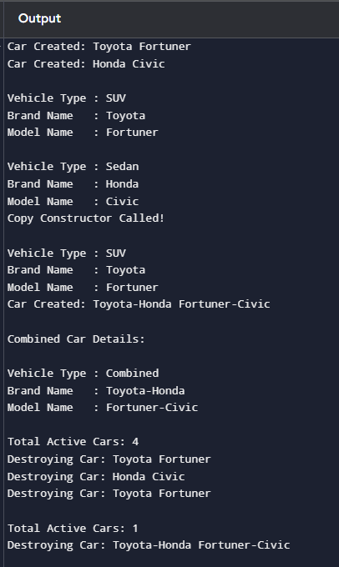

Task no 2:
#include <iostream>
using namespace std;

class Project {
private:
float projectWeight;

public:
Project(float p) {
projectWeight = p;
}

float getProjectWeight() {
return projectWeight;
}
};

class Student {
private:
float quizWeight;

public:
Student(float q) {
quizWeight = q;
}

float getQuizWeight() {
return quizWeight;
}

float calculateTotal(Project p) {
return quizWeight + p.getProjectWeight();
}
};

int main() {

Project p1(40);
Student s1(30);

cout << "Project Weight : "
<< p1.getProjectWeight() << "%" << endl;

cout << "Quiz Weight : "
<< s1.getQuizWeight() << "%" << endl;

cout << "Total Weight : "
<< s1.calculateTotal(p1) << "%" << endl;

return 0;
}

Output:
